
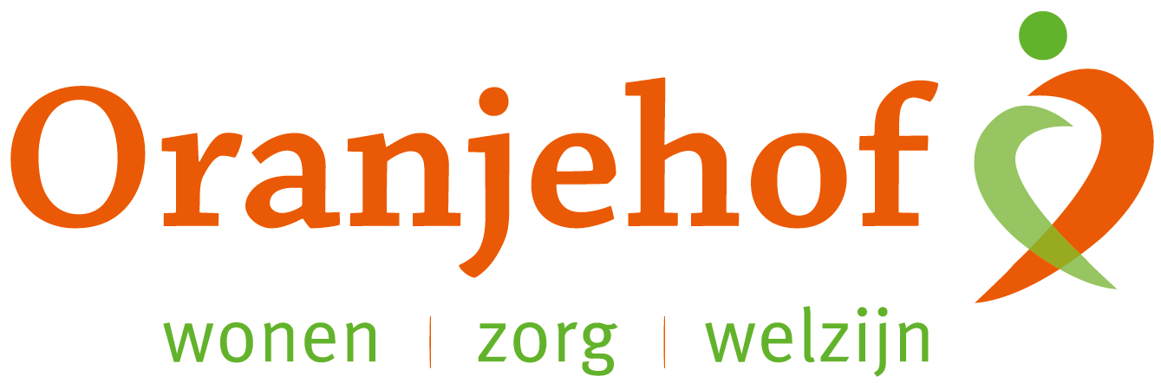

PUZZELEN ORANJEHOF 2025

week 18-19 (1) – maandag 28 april t/m vrijdag 9 mei

Woordzoeker ‘Koningsdag 2025’

ACHTERHOEK  ACTIVITEITEN  APRIL  AUBADE  BINGO  BRADERIE  BUITEN | CONCERT  DOETINCHEM  FEEST  FESTIVAL  GEZELLIGHEID  KINDEREN  KLEEDJESMARKT | KOFFIE  KONING  KONINGIN  KROON  LINTJE  MUZIEK  OPTOCHT | OPTREDEN  ORANJE  ORANJEBITTER  ORANJEBOND  PALEIS  PARK  PILSJE | PRINSESSEN  PROVINCIE  RONDVAART  SJOELEN  SPELLETJES  THEATER  TOMPOUCE | VERJAARDAG VERSIERING  VLAG  VORSTELIJK  VROLIJKHEID  VRIJMARKT  WIMPEL

H | N | T | S | E | E | F | E | E | L | S | L | K | O | N | I | N | G
D | E | K | G | A | L | V | I | E | P | I | IJ | L | I | N | T | J | E
O | L | R | A | E | L | R | P | E | R | L | T | R | E | C | N | O | C
E | E | A | D | N | E | M | L | P | E | P | A | L | E | I | S | P | T
T | O | M | R | D | I | L | A | T | E | C | U | O | P | M | O | T | K
I | J | IJ | A | W | E | D | S | E | T | H | C | O | T | P | O | R | R
N | S | R | A | T | P | R | I | N | S | E | S | S | E | N | V | E | A
C | B | V | J | D | O | D | A | E | E | F | R | O | L | E | T | D | M
H | A | E | R | V | N | D | N | C | H | A | E | P | R | T | V | E | S
E | S | K | E | I | Z | U | M | O | H | G | U | S | I | A | I | N | E
M | E | R | V | T | O | G | N | I | B | T | I | B | T | L | N | F | J
D | I | E | H | K | IJ | L | O | R | V | E | E | L | A | I | S | J | D
E | I | C | N | I | V | O | R | P | R | J | J | R | L | D | V | J | E
N | E | R | E | D | N | I | K | I | N | E | E | N | H | E | E | A | E
K | O | N | I | N | G | I | N | A | K | R | A | P | A | O | Z | S | L
N | E | T | I | U | B | G | R | T | H | E | A | T | E | R | E | E | K
N | O | O | R | K | R | O | N | D | V | A | A | R | T | T | O | K | G
K | O | F | F | I | E | N | E | T | I | E | T | I | V | I | T | C | A

Oplossing: _______________________________________________________________________________________

Inleveren bij de receptie van Oranjehof
Naam: ………………………………………………………………………………………………………………………………………………………………………
Adres: ………………………………………………………………………………………………………………………………………………………………………

