
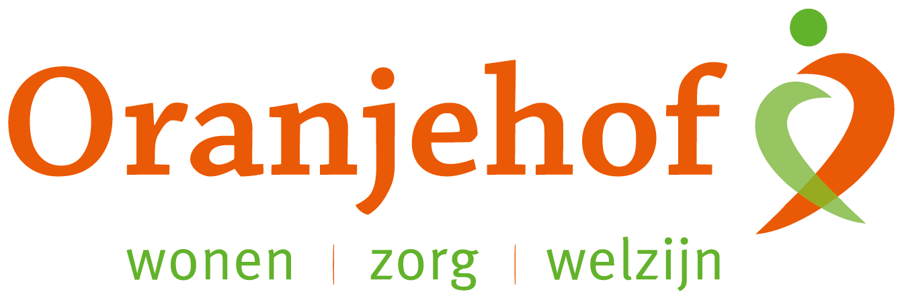

PUZZELEN ORANJEHOF 2025
week 5 – maandag 27 januari t/m vrijdag 31 januari

Plaatsnamen
Vul de ontbrekende klinkers (a, e, i, ij, o, u) in.

- B __ rn __ v __ ld  - D __ d __ w __ __ rd  - __ ss __ lm __ __ d __ n  - __ pp __ ng __ d __ m  - H __ lsh __ rst  - K __ ll __ m __ rzw __ __ g  - __ __ st __ rw __ ld __  - Sch __ rp __ nz __ __ l  - H __ __ rh __ g __ w __ __ rd  - Sl __ __ sk __ l  - D __ v __ nt __ r  - B __ lsw __ rd  - H __ ss __ lt  - Dr __ nt __ n  - __ nt __ r  - B __ rc __ l __  - D __ d __ msv __ __ rt  - Z __ __ msl __ g  - Z __ ltb __ mm __ l  - G __ ld __ rm __ ls __ n | - N __ d __ rh __ m __ rt  - __ ph __ __ sd __ n  - __ __ th __ __ z __ n  - __ __ gt __ k __ rk __  - Z __ __ dh __ rn  - K __ rkr __ d __  - H __ __ nsbr __ __ k  - W __ stk __ p __ ll __  - Gr __ __ t __ g __ st  - N __ v __ rd __ l  - H __ ns __ l __ rsd __ k  - H __ __ nd __ rl __ __  - L __ __ dsch __ nd __ m  - C __ __ v __ rd __ n  - M __ ntf __ __ rt  - __ lbl __ ss __ rd __ m  - L __ p __ k __ rk __ p __ l  - D __ __ rn __ ng __ n  - W __ __ d __ nb __ rg  - __ z __ nd __ __ rn

Inleveren bij de receptie van Oranjehof
Naam: ………………………………………………………………………………………………………………………………………………………………………
Adres: ………………………………………………………………………………………………………………………………………………………………………

