
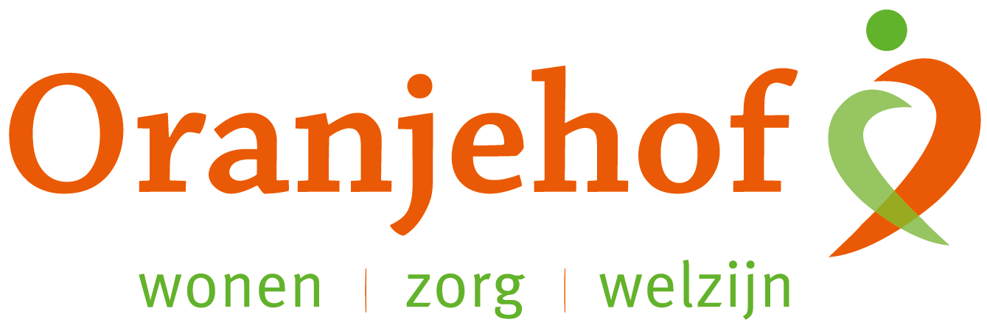

PUZZELEN ORANJEHOF 2024
week 39 – maandag 23 september t/m vrijdag 27 september

Plaatsnamen
Vul de ontbrekende klinkers (a, e, i, ij, o, u) in.

- R __ tt __ rd __ m  - __ __ ndh __ v __ n  - Gr __ n __ ng __ n  - __ p __ ld __ __ rn  - H __ __ g __ v __ __ n  - W __ rk __ nd __ m  - Z __ __ r __ kz __ __  - __ mst __ rd __ m  - H __ lv __ rs __ m  - H __ rd __ rw __ k  - __ nkh __ __ z __ n  - P __ rm __ r __ nd  - __ mm __ l __ __ rd  - D __ rdr __ cht  - Z __ __ dl __ r __ n  - V __ nk __ v __ __ n  - G __ __ th __ __ rn  - D __ __ rnsp __ k  - G __ r __ nch __ m  - T __ rn __ __ z __ n | - M __ __ str __ cht  - L __ __ __ w __ rd __ n  - __ m __ rsf __ __ rt  - R __ __ s __ nd __ __ l  - D __ __ t __ nch __ m  - M __ dd __ lb __ rg  - Vl __ ss __ ng __ n  - __ mst __ lv __ __ n  - V __ lk __ nb __ rg  - W __ nsch __ t __ n  - W __ g __ n __ ng __ n  - Dr __ __ b __ rg __ n  - Zw __ ndr __ cht  - __ __ st __ rb __ __ k  - H __ __ v __ l __ k __ n  - S __ ss __ nh __ __ m  - V __ rss __ v __ ld  - G __ n __ m __ __ d __ n  - W __ nt __ rsw __ k  - __ rn __ m __ __ d __ n

Inleveren bij de receptie van Oranjehof
Naam: ………………………………………………………………………………………………………………………………………………………………………
Adres: ………………………………………………………………………………………………………………………………………………………………………

